|  |  |  |  |
| --- | --- | --- | --- |
| **SVKM's-IOT, Dhule**Shri Vile Parle Kelavani Mandal's  **INSTITUTE OF TECHNOLOGY**  **DHULE (M.S.)**  **DEPARMENT OF COMPUTER ENGINEERING** | | | |
| **Subject :** Java Programming Lab (Seminar-I) | | | Remark |
| **Name :**  Ansari Asharul Ameen Naeem Ahmad | | **Roll No. :** 63 |
| **Class:** SY. Comp. Engg. | **Batch : S4** | **Division: A** |
| **Expt. No. :**08 | **Date :** | | Signature |
| **Title :**  Write Java Programs to demonstrate: Method overloading( Dynamic Polymorphism ( Method Overriding) | | |
|  | | |
|  | | |

**//program 1 :**

// Method Overloading ( Static Polymorphism)

public class StaticPolymorphism {

void fly(){

System.out.println("I am flying");

}

void fly(String s){

System.out.println(s.toUpperCase());

}

void fly(int x){

System.out.println("Area = " + x * x);

}

public static void main(String[] args){

StaticPolymorphism obj = new StaticPolymorphism();

obj.fly();

obj.fly("Overloading");

obj.fly(5);

}

}

// output

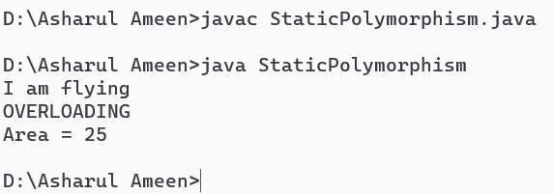

**// program 2:**

// Dynamic Polymorphism ( Method Overriding)

class Parent

{ void print()

{ int x = 10;

System.out.println(x * x); }

}

class DPolyex extends Parent

{ void print()

{ int fact = 1,

n = 5;

for (int i = 1; i <= n; i++)

{ fact = fact * i; }

System.out.println("Factorial: " + fact); }

public static void main(String[] args) {

DPoly s = new DPoly();

s.print(); }

}

// output

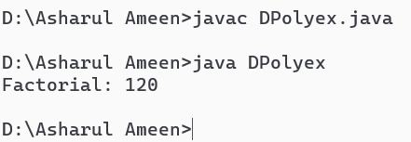88